**Lab 3 – System Linearity**

# Objectives

(

a

)

(

b

)

Fig. 1:

(

a)

TIMS rack configuration for comparator study

. (b)

Wiring Diagram for comparator study

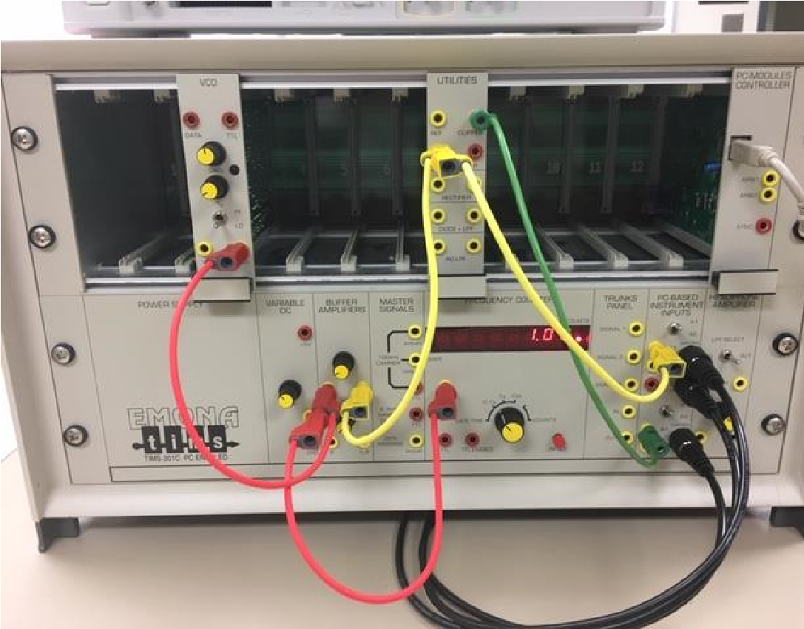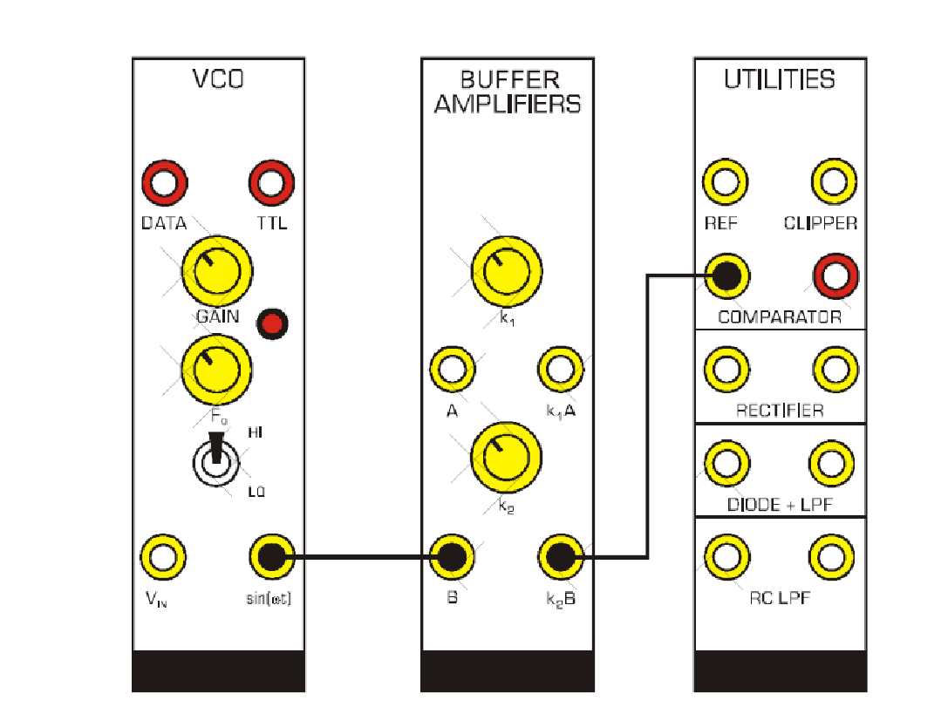

* Understand system linearity

**New Modules for This Lab:**

* VCO
* MULTIPLIER
* VARIABLE DC
* LAPLACE V2

In the previous lab we looked at several systems, in particular filters in the BASEBAND

CHANNEL FILTERS module. Now we look at a few more systems and use these to study linearity. Very early in the Signals & Systems lectures, student are presented with what it means to have a linear time-invariant systems. In Lab 3, we focus in particular on linearity. A system is linear if it satisfies both the scaling and the additive criteria.

# Part A – Linearity: scaling

A voltage controlled oscillator (VCO) delivers a sinusoidal output with frequency dependent on input voltage. The buffer amplifier will be used to control the sinusoid’s amplitude, and this signal will then be fed to a system to study the system’s linearity.

First we will examine two systems in the UTILITIES module: the comparator and the rectifier. Then we will look at the MULTIPLIER module.

# A.1 Comparator

Per the data sheet, a “comparator will square any analog signal and provide a standard TTL level output.”

1. Wire up the VCO and UTILITIES modules as shown in Figure 1.

* Here, the VCO module is inserted into Slot 3 and the UTILITIES module is inserted into slot 7. • Connect the VCO’s sin(t) output to the BUFFER AMPLIFIER’s input “A”, and to the input of the FREQUENCY COUNTER (red leads).
* Connect the BUFFER AMPLIFIER’s output (k1A) to the UTILITIES module COMPARATOR input, and to Scope ChA (yellow leads).
* Connect the UTILITIES CLIPPER output to Scope ChB (green lead).

2. Open PicoScope.

Fig. 2

:

1

Vpp input (blue) and comparator output (red

)

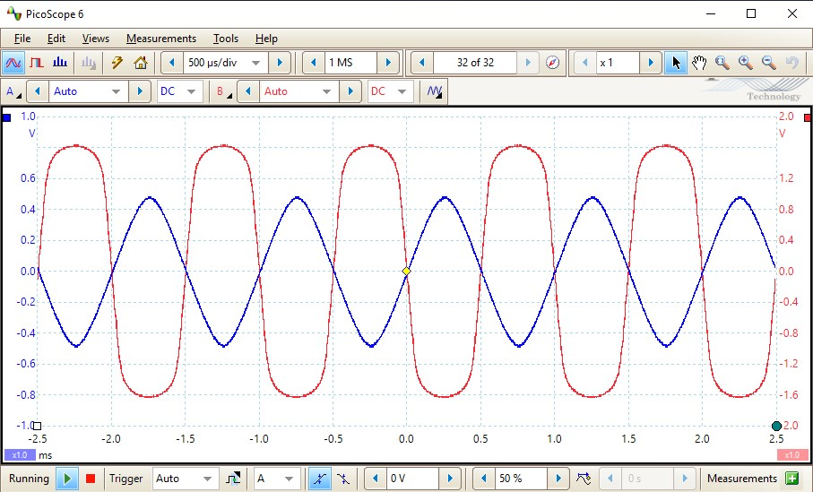

* Turn on ChB (AUTO).
* DC couple both channels.
* Set time base to 500us/div.
* Turn on the TRIGGER (Auto)

3. On the VCO, adjust the f0 knob to achieve close to 1000 Hz.

• While observing the ChA signal on the PicoScope, adjust BUFFER AMPLIFIER gain k1 to achieve a 1Vpp signal. See Figure 2.

4. Now adjust the BUFFER AMPLIFIER gain k1 and record peak-to-peak output values on the blank chart provided in Figure 3, and create such a chart for your lab notebook. *(note: you may print out the blank graphs, fill them in as instructed, and then paste/tape them into your lab notebook).*

• Increase input voltage in 1Vpp increments to collect data.

5. Examine the comparator output in Figure 3. State why you believe this output is either linear or nonlinear.

It appears to be linear as it rises by 0.5 each volt

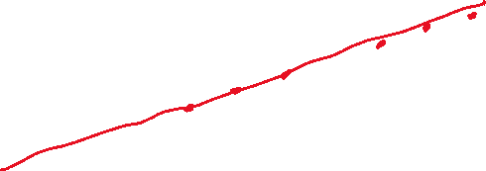

0

1

2

3

4

5

6

7

8

9

10

0

1

2

3

4

5

6

7

8

9

10

Input Vpp (V)

Fig. 3 Blank graph for recording comparator and rectifier system outputs as a function of the input voltage

|  |  |
| --- | --- |
| 1v | 0.5 |
| 2v | 0.9 |
| 3v | 1.4 |
| 4v | 2 |
| 5v | 2.5 |
| 6v | 3 |
| 7v | 3.5 |
| 8v | 4 |
| 9v | 4.5 |
| 10v | 5 |

# A.2 Rectifier

Fig. 5

:

.

Vpp input (blue) and rectifier output (red)

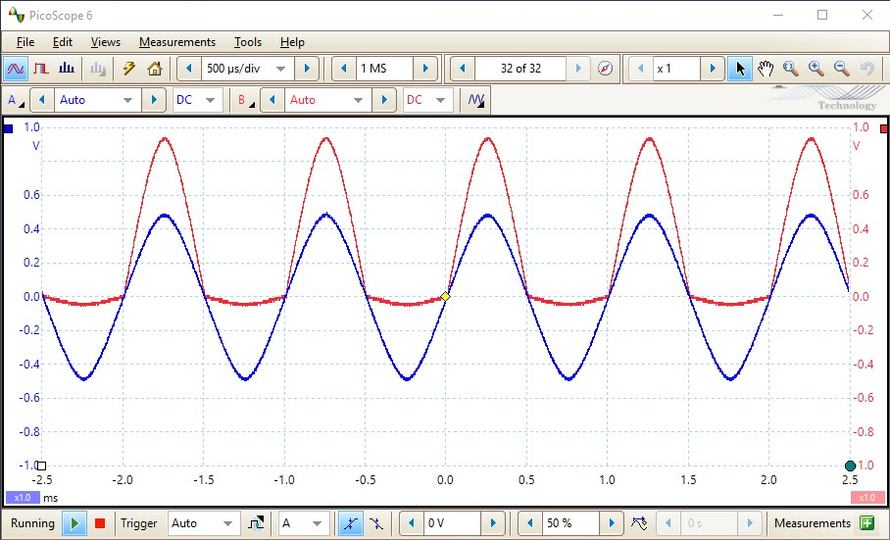

(

a

)

(

b

)

Fig. 4

:

(

a)

TIMS rack configuration for rectifier study

(

b) Wiring

diagram for rectifier study

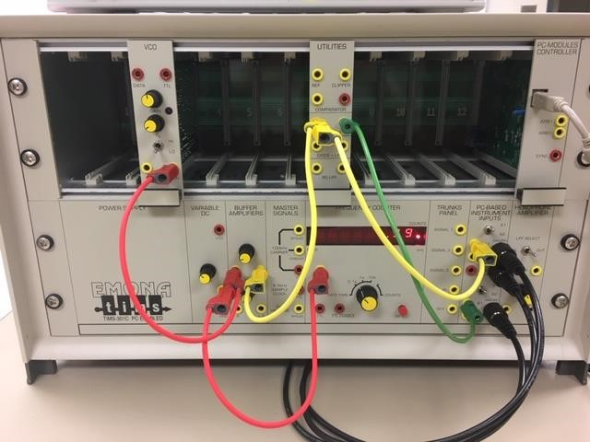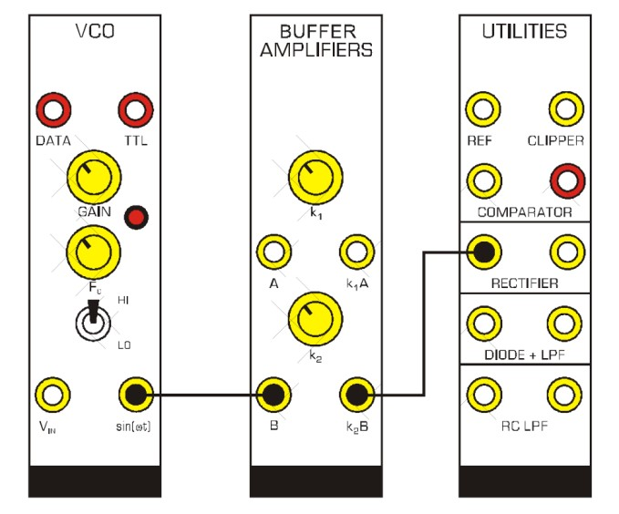

A rectifier will generally acquire the positive portion of an input signal.

1. Modify the previous TIMS configuration to study the rectifier as a system instead of the comparator. See Figure 4.

* Now the BUFFER AMPLIFIER output k1A is connected to the UTILITIES module rectifier input and to Scope ChA(yellow leads)
* Scope ChB is connected to the UTILITIES module rectifier output (green lead).

2. Repeat step 3 from section A.1, returning the input signal to a 1Vpp sinusoid at 1000Hz.

* The PicoScope setting from step 2 should be fine.
* See Figure 5.

3. Repeat step 4 from section A.1, adjusting the input signal amplitude in 1Vpp increments while adding the peak-to-peak output of the rectifier to the graph of Figure 3 in your lab notebook.

|  |  |
| --- | --- |
| 1v | 0.6 |
| 2v | 0.8 |
| 3v | 1.2 |
| 4v | 3.8 |
| 5v | 2.5 |
| 6v | 3.0 |
| 7v | 3.3 |
| 8v | 4.0 |
| 9v | 4.4 |
| 10v | 8.8 |

• Note that the rectifier output peak-to-peak is approximately just the height of the output, since the negative portion is removed.

4. Examine the rectifier output in Figure 3.

State why you believe this output is either linear or nonlinear.

Nonlinear. Does not rise in a straight line

# A.3 Multiplier

Linear systems must also exhibit “additivity”. Consider a linear systems where y1(t) = Ax1(t) and y2(t) = Ax2(t). Then, the additive condition requires for an input signal x1(t) + x2(t), the output must be A(x1(t) + x2(t)).

Now consider a system that squares the input signal. Thus, for x(t) = Asin(t), then y(t)=A2sin2(t). By the half angle formula, we know

A2sin2(t) = ½ A2(1-cos(2t))

Clearly, such a system fails the additivity requirement! It also fails the scaling requiring as we will see.

In this experiment, we generate a sinusoid using the voltage controlled oscillator (VCO), control its amplitude with the BUFFER AMPLIFIER, and then feed its output into both inputs of the MULTIPLIER.

1. In order for the following instructions to match what you will be seeing, it is convenient to start fresh.

(

a

)

(

b

)

Fig. 6:

(

a)

TIMS

rack configuration for multiplier

study

(

b) Wiring

diagram for multiplier study

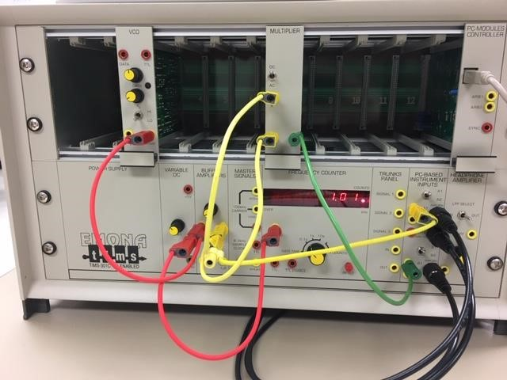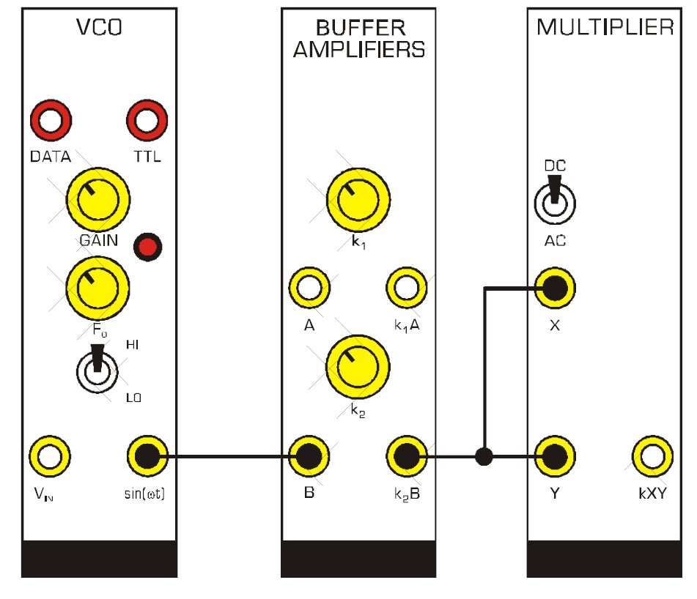

• Disconnect all leads and turn off the PicoScope.

2. Wire up the TIMS rack as shown (see Figure 6).

* Ensure the VCO on-board switch is set to

“VCO” and not “FSK”. Insert this module into the TIMS rack.

* Insert the MULTIPLIER module into the TIMS rack.

3. Connect the VCO output to the BUFFER AMPLIFIER input and to the

FREQUENCY COUNTER (red leads).

• Adjust the VCO knob to achieve 1 kHz.

1. Connect the BUFFER AMPLIFIER output both the inputs of the MULTIPLIER, and to Scope ChA. (yellow leads).

1. Connect the MULTIPLIER output to Scope ChB (green lead).

6.

Fig. 7:

input (blue) and output (red) for the multiplier.

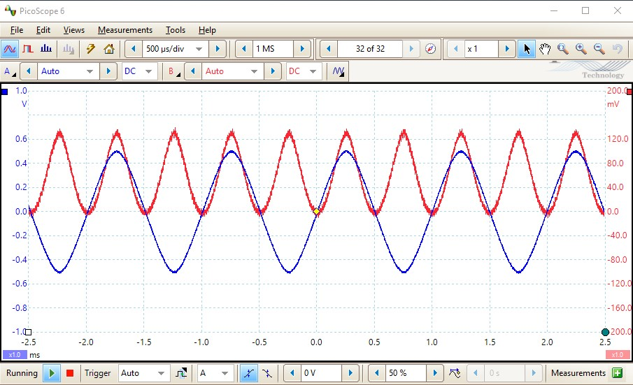

* Turn on Channel B.
* Set both channels to DC coupling
* Stabilize the scope output using Trigger

(Auto)

* Adjust the time base to view a convenient number of cycles.

1. Adjust the input signal amplitude (BUFFER AMPLIFIER k1 knob) to

achieve a 1Vpp input (i.e. a 0.5V input amplitude) as viewed on the PicoScope.

See Figure 7.

1. Consider the output signal as in Figure 7. Its average, or DC, value should be the same as its amplitude.



Fill in this output amplitude in Table 1. This table should be recreated or inserted in your lab notebook. • You may need to use the zoom and cursor tools to get an accurate reading. Table 1



|  |  |
| --- | --- |
| Input Amplitude | Output Amplitude |
| 0.5 | 0.34 |
| 1.0 | 0.51 |
| 1.5 | 0.55 |
| 2.0 | 1.2 |
| 3.0 | 2.6 |
| 4.0 | 2.13 |

1. Continue to fill in Table 1 for the input amplitudes listed.

Fig. 8 Blank graph for recording Table 1 Multiplier data

0

1

2

3

4

5

6

0

1

2

3

4

5

Output Amplitude (V)

Input Amplitude(V)

1. Plot the results of Table 1 in the Figure 8 blank graph provided, which should be inserted or recreated in your lab notebook.

Answer the following questions in your lab notebook:

Q1: Is your system linear?

Note that the application of the additivity test is not needed when the scaling test has failed.

No. Nonlinear

Q2: In the introduction to this section, the half angle formula showed the amplitude of the output is half the square amplitude of the input. Is this demonstrated in Figure 8? If not, why not? (hint: see the MULTIPLIER module spec sheet).

# Part B – The VCO as a System

A voltage controlled oscillator (VCO) delivers a sinusoidal output with frequency dependent on input. Here we explore the output characteristics of the VCO with different control inputs.

# B.1 DC Control

1. In order for the following instructions to match what you will be seeing, it is convenient to start fresh.

(

a

)

(

b

)

Fig. 9:

(

a)

TIMS rack configuration for

study of a

DC controlled

VCO

system. (b) Wiring diagram for study of DC controll

ed

VCO

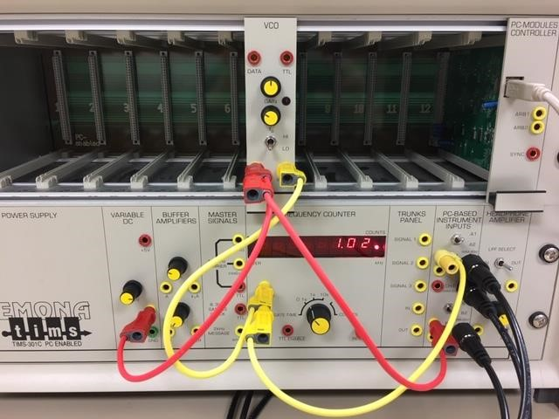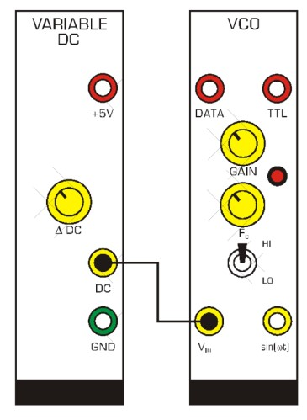

• Disconnect all leads and turn off the PicoScope.

2. Assemble the TIMS rack for the DC controlled VCO study (see Figure 9).

* Ensure the VCO on-board switch is set to

“VCO” and not “FSK”. Insert this module into the TIMS rack.

* The VCO toggle should be set to “LO”
* Set VCO gain and fo knobs about in the center of their rotation
* *See also the VCO module spec sheet, in particular the section on “Special VCO Operation”*

1. Connect the VARIABLE DC output to the input of the VCO, and to Scope ChB.

(red leads)

1. Connect the VCO output to the FREQUENCY COUNTER and to Scope

ChA. (yellow leads).

5.

Fig.

10:

Typical view of DC control value (red

trace

)

and sinusoidal

output (blue

trace

)

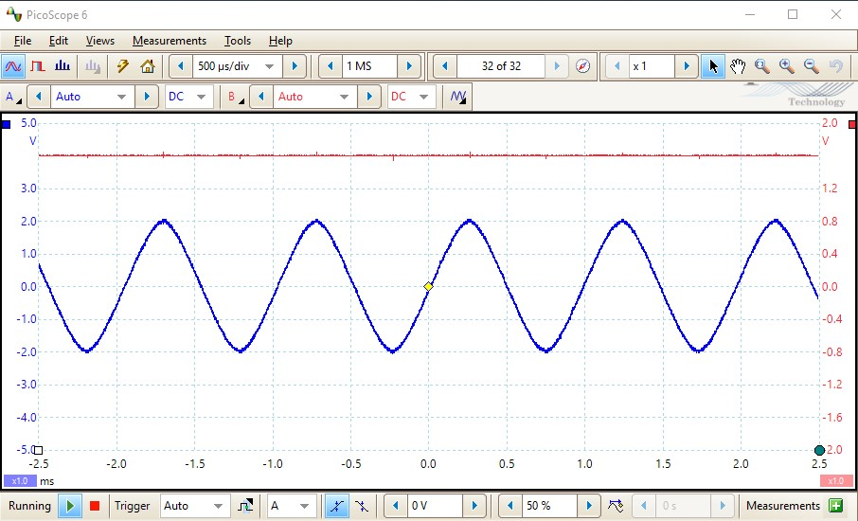

* Turn on Channel B.
* Set both channels to DC coupling
* Stabilize the scope output using Trigger

(Auto)

* Adjust the time base to view a convenient number of cycles. See Figure 10.

1. Adjust the DC output to -2V as displayed on the PicoScope. Record the frequency

(from the FREQUENCY COUNTER) in

Table 2, duplicated in your lab notebook.

1. Continue adjusting the DC output and fill in Table 2.

|  |  |
| --- | --- |
| DC value (V) | Signal frequency (Hz) |
| -2 | 1.20 |
| -1 | 1.09 |
| 0 | 0.98 |
| 1 | 0.89 |
| 2 | 0.80 |

1. Plot the values of Table 2 in the blank graph provided (Figure 11), duplicated in your lab notebook. Table 2

Fig. 11

Blank graph for recording

Table 2 DC controlled VCO data. Set

your own vertical axis scaled based on the range of outputs in Table 2.

-2

-1

0

1

2



|  |
| --- |
|  |
|  |
| Fig. 15 The sinusoidal input to the VCO (red trace) and the  corresponding VCO output (blue trace).Fig. 12 (a): TIMS rack configuration for study of a frequency  controlled VCO system. (b) Wiring diagram for study of a |
| frequency controlled VCO system |

# B.2 Frequency Control

1. In order for the following instructions to match what you will be seeing, it is convenient to start fresh.

• Disconnect all leads and turn off the PicoScope.

1. The configuration for a frequency controlled VCO study is shown in Figure 12 with AUDIO OSCILLATOR and VCO modules inserted into the TIMS rack.

1. Connect the AUDIO OSCILLATOR’s sin(t) output to Input A of the BUFFER AMPLIFIER, and to the FREQUENCY COUNTER’s ANALOG input (red leads).

• Adjust the AUDIO OSCILLATOR’s

sin(t) output to achieve 300 Hz on the

FREQUENCY COUNTER.

4. Connect the BUFFER AMPLIFIER k1A output to the VCO’s Vin input, and to Scope ChB (yellow leads).

• You may need to recue the VCO gain to turn off the red overload LED.

5. Connect the VCO’s sin(t) output to Scope ChA (green lead).

6.

Fig. 13

The sinusoidal input to the VCO (red trace) and the

corresponding VCO output (blue trace).

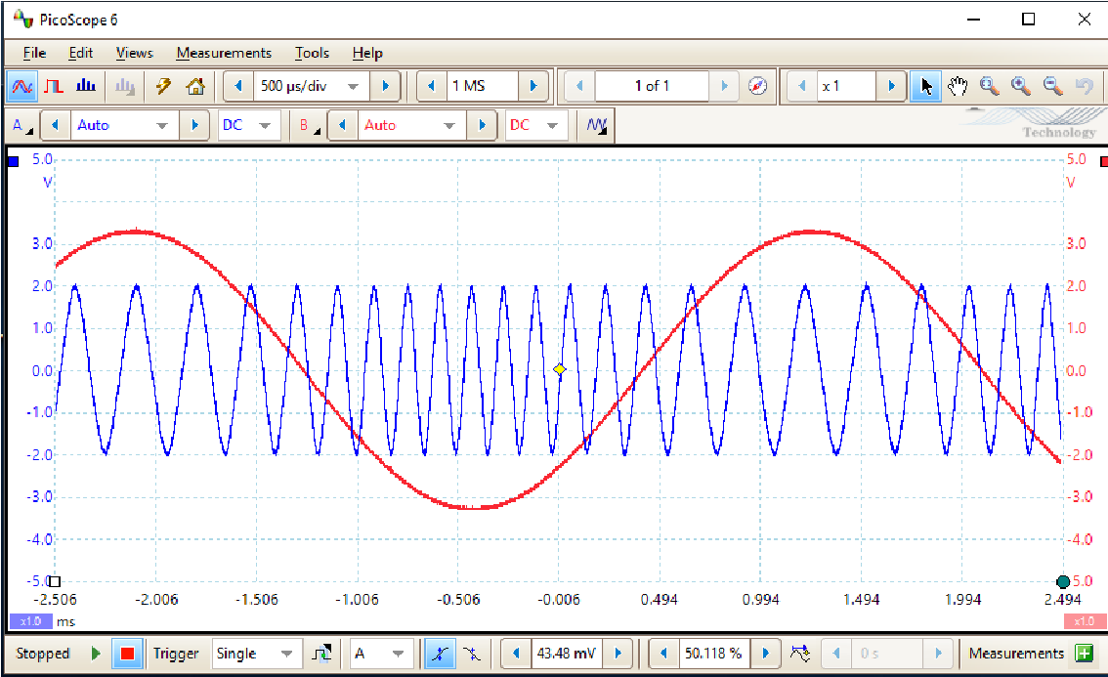

* Turn on Channel B (Auto)
* Set both channels to DC coupling (this is the default setting)
* Decrease the time base to improve the appearance of both the input and the output sinusoids (for instance, 500us/div). • Employ Single Shot Triggering. Press the Trigger’s green arrow to view several scans. See Figure 13.

Q: Notice that the input signal controls, or *modulates*, the output signal frequency. When the input is at the high end of the sinusoid, the frequency of the output is decreased. When the input is at the low end of the sinusoid, the output frequency is increased. What is an obvious application of a system that behaves this way?

Sound for higher or lower pitch

# – Feedback System

In Signals and Systems lecture, you will (or will have) learned the Laplace transform for an integral:

𝑡 ′)𝑑𝑡 1

∫ 𝑥(𝑡 ′ ↔𝑋(𝑠)

𝑠

0

The Laplace V2 module has three integrators, and the integration in each one is denoted by an “S-1”. In the first part of this lab, we will demonstrate operation of an integrator. In the second part, the integrator will be part of a feedback system.

## The Integrator

Fig.

15

feedback system part 1

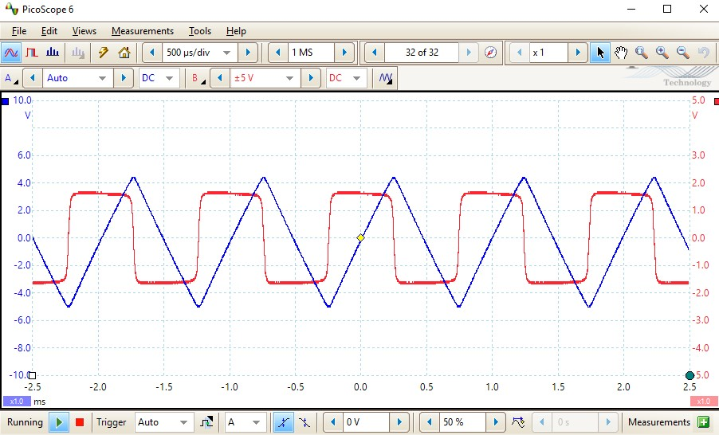

Fig. 14

:

TIMS rack con

figuration for feedback system

part 1

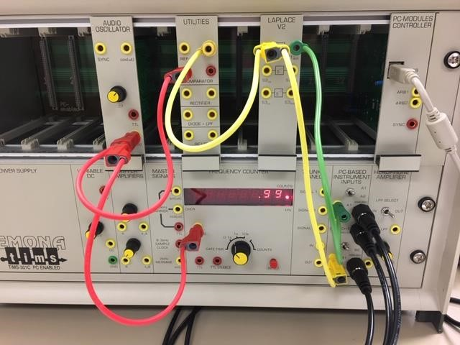

1. Start fresh. Disconnect all leads and turn off the PicoScope.

1. The configuration for study of the integrator is shown in Figure 16 with

AUDIO OSCILLATOR, UTILITIES and LAPLACE V2 modules inserted into the TIMS rack.

1. Connect the AUDIO OSCILLATOR’s sin(t) output to the UTILITIES COMPARATOR input (this is the *Analog Signal Input* on the module spec sheet) and

to the FREQUENCY COUNTER’S

Analog input (red leads).

• Set the AUDIO OSCILLATOR’s f knob to achieve 1 kHz.

1. Connect the UTILITIES output (this is the *Clipper Bipolar Output* on the module spec sheet) to the LAPLACE V2’s S1in and to Scope ChB (yellow leads).

1. Connect LAPLACE V2’s S1out to Scope ChA (green lead).

1. Open the PicoScope.

* Turn on Channel B (+/- 5V)
* Set both channels to DC coupling (this is the default setting)
* Decrease the time base to 500us/div
* Stabilize the scope output using Trigger (Auto). See Figure 15.

Q: Describe how the scope display demonstrates operation of the integrator.

**The blue output (integrator) us showing the integral of the red input. The red input seems to be a unit step function and the integral of that would be a ramp function, which is what the blue is showing. The output downslopes when the step function goes negative and slopes up when the step function goes positive.**

## Feedback System

Fig. 16

:

TIMS rack configur

ation for feedback system

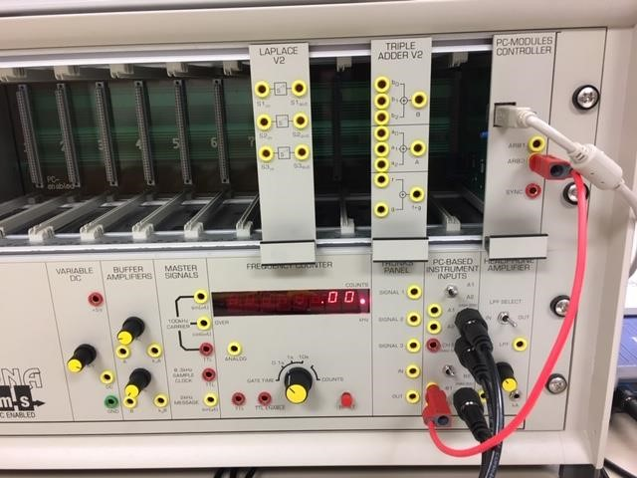

Now that we have some understanding of what the LAPLACE V2’s integrator does, we’ll apply it to a signal from ARB1.

1. In order for the following instructions to match what you will be seeing, it is convenient to start fresh.

• Disconnect all leads and turn off the PicoScope.

1. The configuration for the feedback study begins with insertion of the LAPLACE V2 and TRIPLE ADDER V2 modules into the TIMS rack as shown in Figure 16.

1. Let’s take a look at the PC MODULES CONTROLLER ARB2 signal we will use as the system input signal. Connect the ARB2 output to Scope ChA (red lead).

1. Open the PicoScope and adjust it to view the ARB2 signal (before turning on the SFP).

1. Turn on the S&S V2 SFP application. Select the experiment TAB labeled “Lab 3” and then press the

“LOAD ARB” button. See Figure 17.

Fig. 17

:

TIMS rack configuration for feedback

system part 1

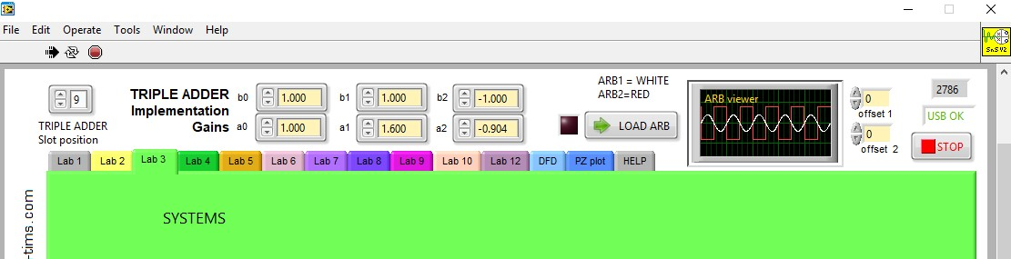

(

a

)

(

b

)

F

ig. 18

:

(

a)

ARB2 output

after activating “Load ARB” in the

SFP

window. (b) Zoom in on a transition.

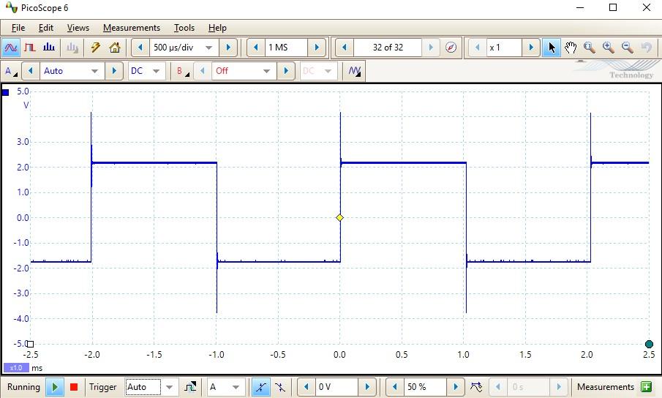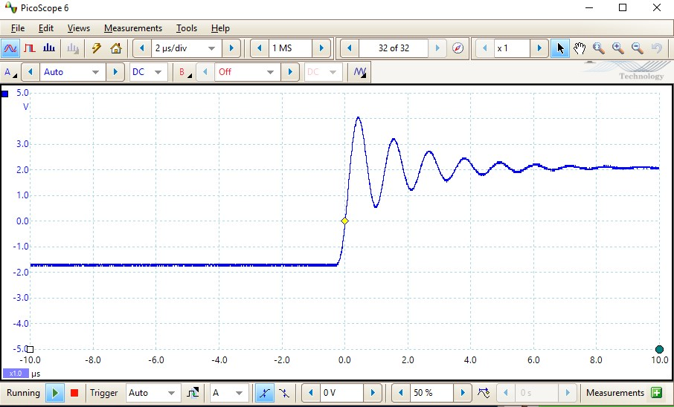

1. Now view the signal on the PicoScope. See Figure 18a

1. In Figure 18b, we zoom in on the transition region to demonstrate the *Gibbs Phenomena.*

1. The TRIPLE ADDER settings must be properly set up on the SFP window before proceeding.

* Make sure the TRIPLE ADDER Slot Position is selected to match the slot in the TIMS rack holding the TRIPLE ADDER.
* Set gain b1 to =1 and gain b2 to -1.
* See Figure 17.

Now we will assemble the feedback circuit shown in the block diagram of Figure 19.

Fig. 19

:

block diagram

representation of the feedback system

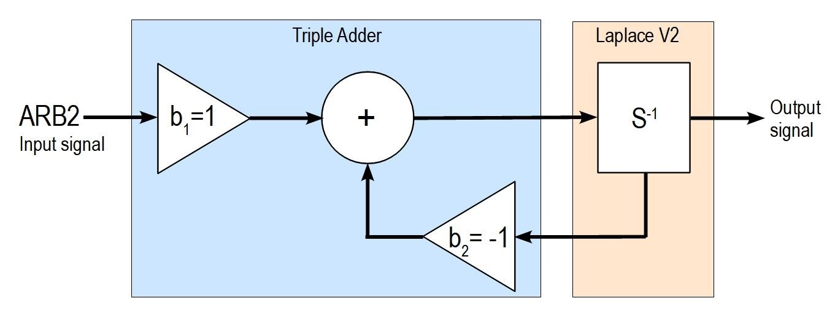

9. Figure 20 shows the TIMS configuration for the feedback study.

(

a

)

b

)

(

Fig. 20

:

(

a)

TIMS rack con

figuration for feedback study

. (b)

Wiring diagram for feedback study

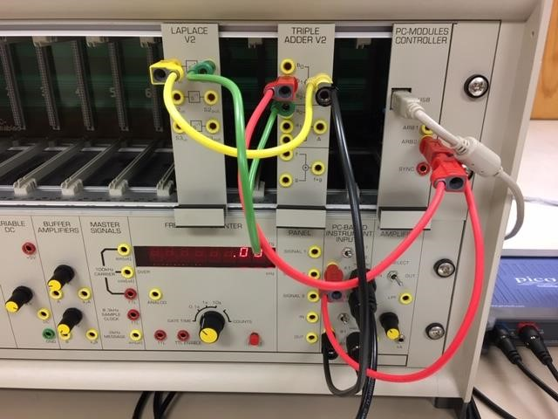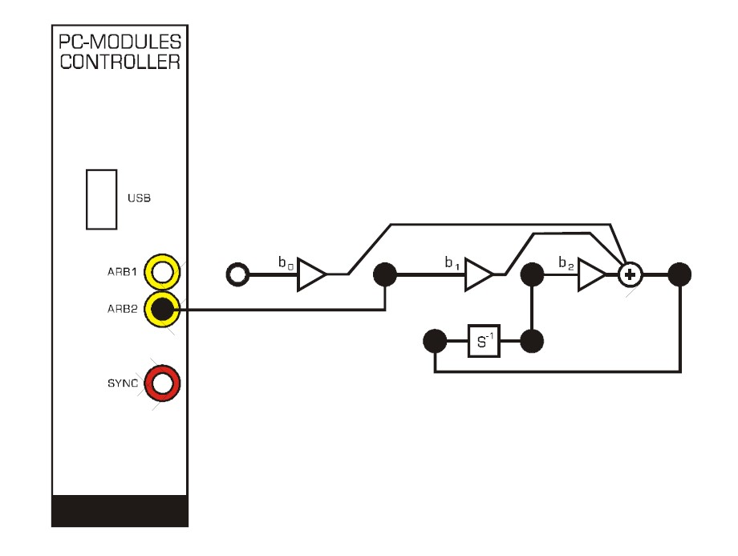

Fig. 21

:

ARB2 input signal (blue trace) and Triple Adder output

(

red trace

)

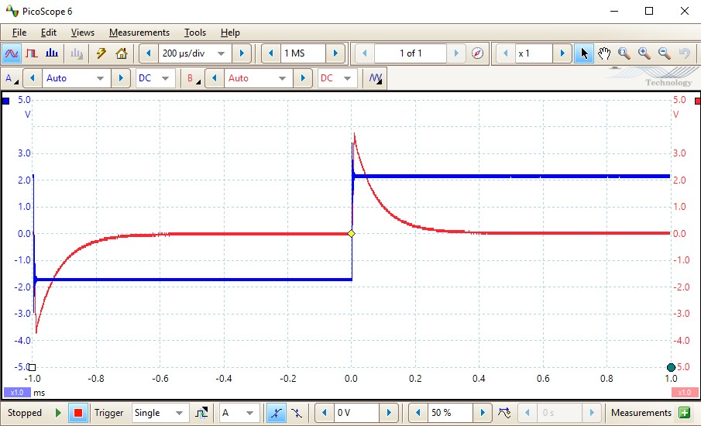

* The ARB2 output should still be connected to Scope ChA. Now also connect the ARB2 output to the b1 input of the TRIPLE ADDER (red leads).
* Connect output B of the TRIPLE ADDER V2 module to S1in of the LAPLACE V2 module (yellow lead).
* Connect S1out of the LAPLACE V2 module to the b2 input of the TRIPLE ADDER V2 module (green lead).
* Now connect the TRIPLE ADDER output B to Scope ChB (black lead).

10. Open the PicoScope.

* turn on Channel B (Auto)
* reduce time scale to 200 us/div• employ single shot triggering.
* See Figure 21

Figure 23 shows the input signal (blue trace) and the output of the triple adder (red trace). Zoomed in this way, the input signal appears to be a step input, and the output signal appears to be the step response. In this case the output is an exponential decay.

1. On the scope, measure and record the time taken for the exponential curve to decrease to e-1 of its initial value. This is the time constant.

69.97 uS

1. Now study the integrator output compared to the system input by changing the Scope ChB cable as shown in Figure 22. • Figure 23 shows the output.

Fig. 22

:

TIMS rack configuration for feedback study

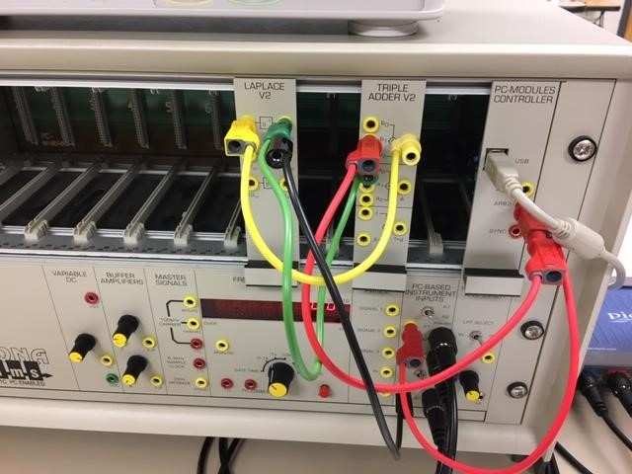

Fig. 23

:

ARB2 input signal (blue trace) and

Integrator

output (red

trace)

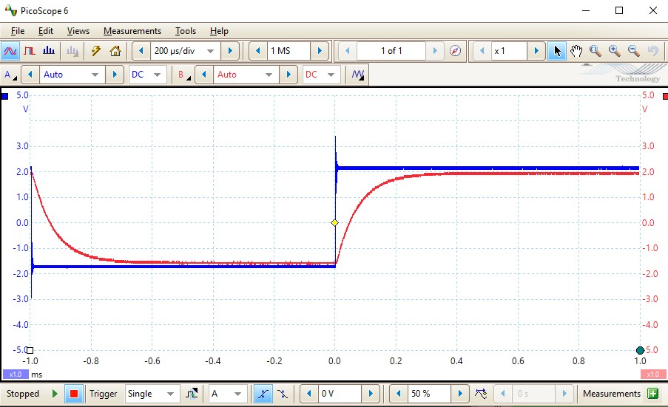

1. Change the scope connections to look at the input to the integrator along with its output. Examine the integrator input and confirm that it looks like the impulse response corresponding to the step response at the integrator output.

**THIS ENDS LAB 3**